Mario Kart 8 Component Analysis Based on Bayesian Hierarchical Model

Linn Wang, Maddy Nomer

Introduction

Mario Kart 8 is a popular racing video game where players compete against each other, using different characters, vehicles, tires, and gliders. When deciding their racing components, players are faced with many choices. A key aspect of the game lies in the customization of the racing components. There are over 480,000 possible combinations, each with different performance metrics. Performance metrics can be influenced by attributes such as speed, acceleration, handling, traction, and weight. However, there are known trade-offs, as higher speed can cause lower acceleration, and lighter characters tend to have higher acceleration but lower speed. Additionally, lighter characters accelerate quickly and handle better but lack speed. Therefore, the optimal configuration for performance is not straightforward and is highly dependent on the players strategy.

To continue, one’s choice in combinations significantly impacts their performance. Given the complexity and interdependence of these variables, a data-driven approach can uncover important patterns. This project aims on applying Bayesian statistical models to predict and analyze the best combinations in Mario Kart 8. Specifically, it will analyze how different components contribute to the performance of various characters. Bayesian methods will allow incorporation of prior knowledge about the game’s physics and characters, while updating beliefs based on observed data. Overall, this project investigates the best combination of components using bayesian inference.

Dataset

The data for this project consists of four different datasets containing different performance attributes for each component in Mario kart 8 and a fifth dataset, which is the world record data. Each component dataset refers to a specific part of the game configuration, which are drivers,vehicles,tires,and gliders.

The drivers dataset includes data on the 41 different characters, along with 14 other attributes. These attributes cover performance features, such as speed(ground,water,air,anti-gravity), handling(ground,water,air,anti-gravity), acceleration, weight, traction, and mini-turbo.) Each driver has a unique set of characteristics that impact performance. The vehicles dataset includes information about the 40 different karts and bikes, along with the same 14 characteristics included in the drivers dataset. The tires dataset contains information about the 21 different tire options, also including the same 14 characteristics. Tire selection can impact traction, speed, and acceleration which can impact player performance. The gliders dataset includes information about the 14 gliders, and the 14 performance characteristics. The glider's impact on performance is less significant than the other components.

All four datasets contain the same 14 performance characteristics. Ground speed,water speed, air speed, and anti-gravity speed describe the speed within specific conditions. Acceleration is how quickly top speed is reached, weight impacts stability and collisions, and handling measures for ground,water,air,and anti-gravity. Traction refers to the vehicle's grip and mini-turbo captures speed-boosts through drifting.

The four datasets were combined into one to analyze the different component types and the combined performance for each driver. A combined dataset allows for direct comparison of the four different components and their effects. The combined dataset creates all the possible combinations of drivers, vehicles, tires, and gliders and results in about 482,000 different combinations. For each configuration, performance attributes such as speed, acceleration, handling, traction, and weight were calculated by summing the respective attribute values by each of the four components. Creating each potential component allowed for a direct comparison of how each component type contributes to the overall performance. However, this is just a basic relationship of the attributes, and the real relationship between the attributes of each component type is much more complex.

The world record dataset contains configuration data from the top performing players. The world record dataset was analyzed to identify patterns in component selection among top performing players. This dataset includes configuration data from top players, which includes details about character selections and part usage in events. This real-world dataset is a resource to the theoretical component attributes.

Exploratory Data Analysis

Before developing Bayesian models, exploratory data analysis(EDA) was performed to gain a better understanding of the data. The EDA began with visualizing distributions of key performance metrics(speed, acceleration, traction) across each component type(drivers, vehicles, tires, and gliders. These visualizations helped identify any skewed distributions or outliers within the data.

Within each component type, correlations between various attributes were examined. The correlations revealed key relationships that could influence the performance of the models. As shown in Figure 1, the features with the strongest positive correlation are acceleration and miniturbo(0.99), ground handling and air handling(0.94), and groundspeed and weight(0.93). In contrast, the features with the strongest negative correlation are acceleration and ground speed(-0.93), mini turbo and ground speed(-0.95), and air handling and ground speed(-0.9). These correlations confirm the trade-offs inherent in the game's mechanics and demonstrates how selecting one attribute requires sacrificing performance in another attribute. The correlations indicate which attributes pair well together, and which attributes may be impacted by choosing another attribute.

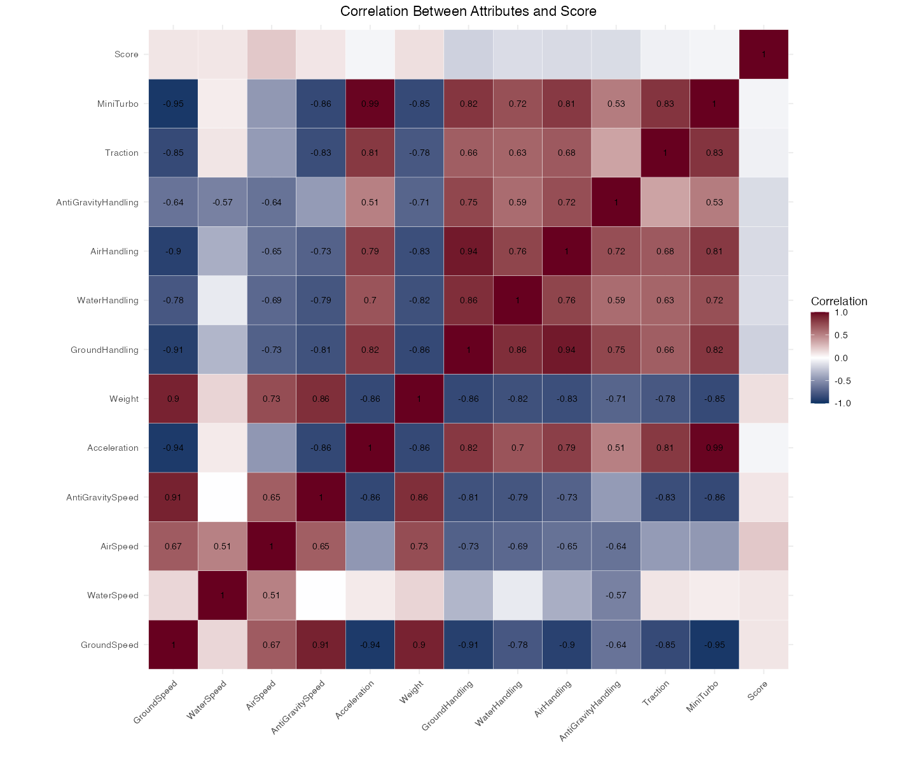

Figure 1: Correlation matrix of attributes

The world record data was analyzed, and the occurrence of different players was looked at. From examining the world record data, it revealed that Wario is one of the most frequently selected characters, as he has a count of 1500+. Wario is not considered an original character, which suggests this selection could be driven by performance, rather than character. In contrast, Kamek is not a popular character, as he has a count of less than 500. This indicates that he may not be chosen, due to performance attributes.
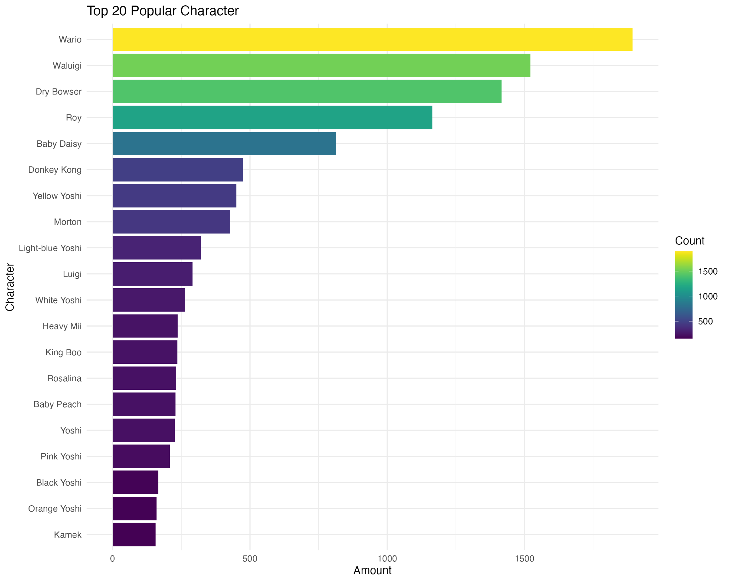
Figure 2: Top 20 popular characters

Moreover, the popular combinations of components were explored. The world record data was analyzed, and the different player configurations were counted. The most popular configuration is Waluigi, with the Biddybuggy vehicle, Azure Roller tires, and a Paper glider, as shown in Figure 3. This configuration has a count of over 500. This differs from Figure 2, as Figure 2 conveys that Wario is the most frequently picked character. It was interesting to see that besides Waluugi, the drivers in the top 10 combinations are different. However, more than half of the combinations include the Biddybuggy vehicle, paper glider, and Azure roller tires. Some of the combinations contained all three, while others contained one or the other.

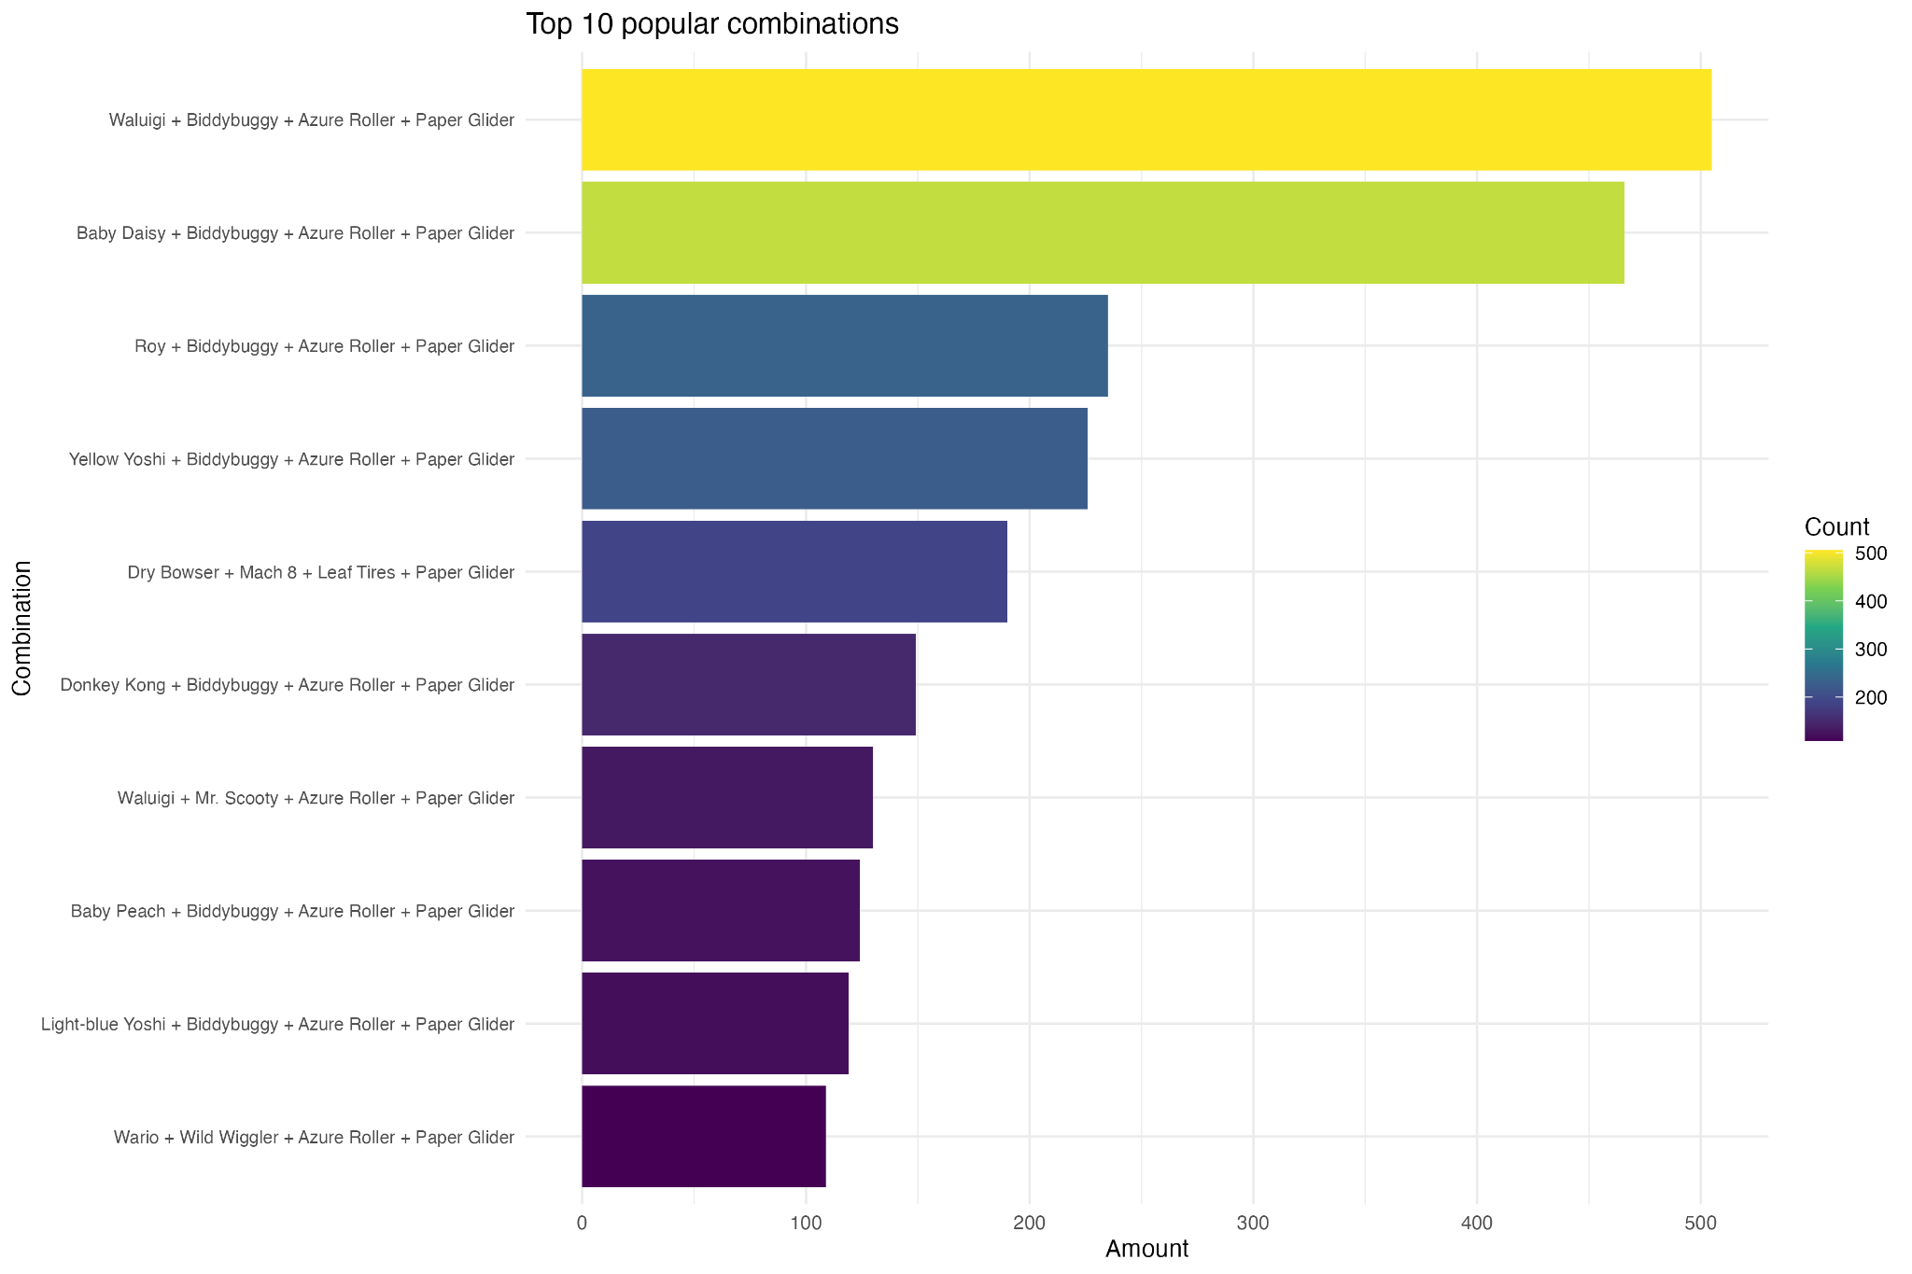
Figure 3: Top 10 popular combinations

Figure 4 analyzes the relationship between characters and their overall performance scores. The analysis revealed that Funky Kong, Lemmy, and Yellow Yoshi had the highest average score across different configurations, over 110,000. In contrast, Daisy, Luigi, and Koopa Troopa showed low average scores of less than 80,000. This performance difference highlights why certain characters appear more frequently in competitions. The high scoring characters may have attributes that better align with the game’s scoring mechanisms, which offers advantages.

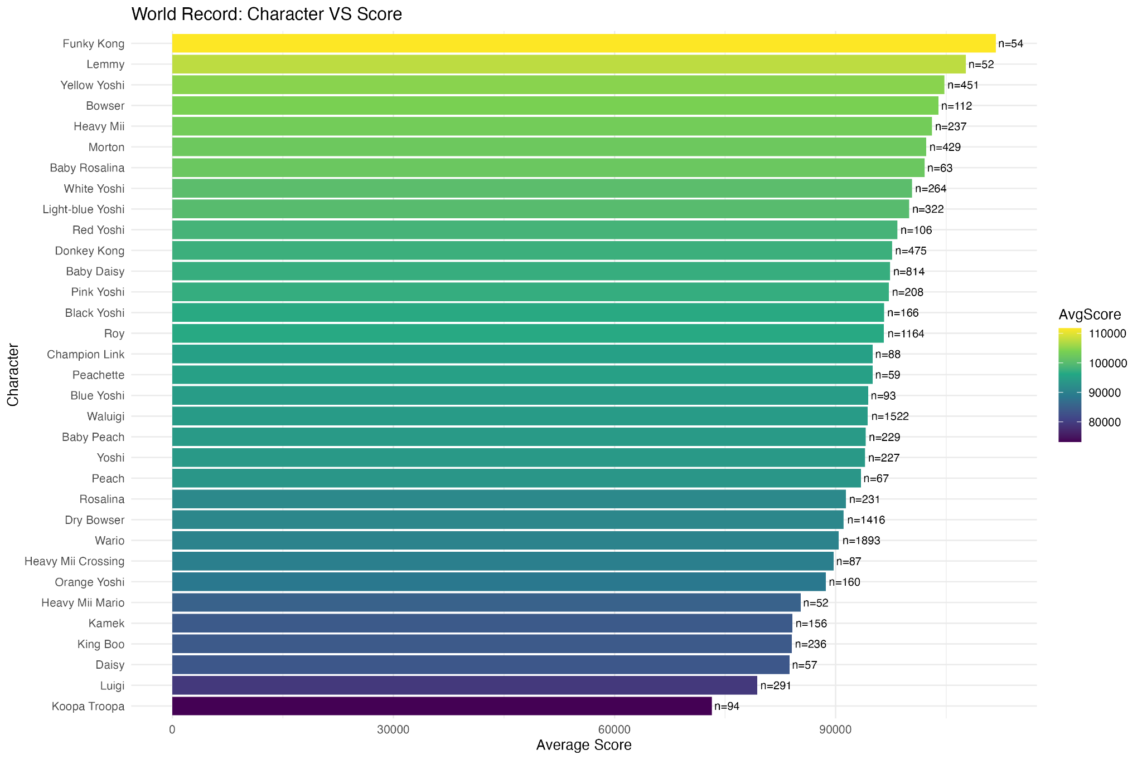
Figure 4: World Record Character vs Score

Methodology

The analytical approach used for this project was based on Bayesian statistical modeling, which offers a way to incorporate prior beliefs and update them on observed data. The three models created were a component contribution model, performance trade-off model, and attribute-based optimization. The component contribution model estimates the individual contribution of each component to the overall performance metrics. This allows for quantification of how each component impacts the configuration's success. In addition, the performance trade off model evaluates the trade-offs between performance attributes. For example, one known trade off is the relationship between speed and acceleration. By modeling these attributes, we can understand the trade off between one attribute and another. Bayesian inference allows the uncertainty of these trade-offs to be captured. Moreover, the character-vehicle interaction model analyzes how specific combinations of vehicles and characters perform together, beyond individual contributions. This model looks at the effects of specific drivers and vehicles being paired. Finally, the optimal configuration prediction model predicts the best possible configuration of components. It applied calculated attribute weights to all possible combinations to identify optimal configurations, using a standardized function. This approach helps identify which attributes contribute most significantly to top performing configurations.

Hierarchical Bayesian Model
Our analysis of Mario Kart 8 components employed a hierarchical Bayesian model with the following mathematical expression:
Score_i ~ Normal(μ_i, σ_y)

μ_i = α + character_effect[character[i]] +
vehicle_effect[vehicle[i]] +
tire_effect[tire[i]] +
glider_effect[glider[i]] +
char_vehicle_interaction[character[i], vehicle[i]] +
Σ(attr_weights[k] * (character_attr[character[i], k] +
vehicle_attr[vehicle[i], k] +
tire_attr[tire[i], k] +
glider_attr[glider[i], k]))
Where:
- Score_i is the standardized score for observation i
- μ_i is the expected score for that observation
- α is the global intercept
- character_effect, vehicle_effect, tire_effect, glider_effect represent the main effects of each component
- char_vehicle_interaction captures specific interaction effects between characters and vehicles
- The final term is the dot product of attribute weights and component attribute values, representing attribute-based contributions

Prior Distributions
The model uses the following prior distributions:
// Global intercept and attribute weights
α ~ Normal(0, 1)
attr_weights ~ Normal(0, 0.5)

// Component main effects
character_effect ~ Normal(0, σ_character)
vehicle_effect ~ Normal(0, σ_vehicle)
tire_effect ~ Normal(0, σ_tire)
glider_effect ~ Normal(0, σ_glider)

// Interaction effects
char_vehicle_interaction ~ Normal(0, σ_interaction)

// Hyperpriors for variance parameters
σ_character ~ Cauchy(0, 1)
σ_vehicle ~ Cauchy(0, 1)
σ_tire ~ Cauchy(0, 1)
σ_glider ~ Cauchy(0, 1)
σ_interaction ~ Cauchy(0, 0.5)
σ_y ~ Cauchy(0, 1)

The selection of priors in the Bayesian models was from a combination of domain knowledge and assumptions about game mechanics. Foremost, game mechanics knowledge was an important prior, as it uses known design principles of Mario Kart 8. For example, it is known that heavier characters tend to have higher top speed but lower acceleration, while lighter characters have opposite traits. These relationships informed the prior distributions of speed and acceleration attributes. In addition, component type interaction was used to weigh priors based on the influence of each component. Player experience indicates drivers and vehicles have the largest impact on performance, while gliders have less of an impact. This played a role in assigning priors, as more flexible priors were given to drivers and vehicles. Moreover, the trade off relationships were conveyed in the priors to emphasize the correlations observed during EDA. For example, the trade-off between speed and acceleration was noted to ensure the model didn’t favor configurations that maximize both attributes. Finally, hierarchical priors were used to account for inconsistencies within each component type. This allowed for component-specific effects to be modeled while information is shared across different groups.

Parameter Estimation Method
We used Hamiltonian Monte Carlo (HMC) through Stan implementation. The parameter estimation process included:
- 4 independent Markov chains
- 2,000 iterations per chain with 1,000 warmup iterations
- Posterior distributions obtained by pooling non-warmup samples across all chains
- Point estimates using posterior means, with uncertainty assessed via 95% credible intervals

MCMC Diagnostics
To ensure reliable posterior estimates, we conducted rigorous convergence diagnostics:
- Gelman-Rubin statistic (R̂): All parameters had R̂ values < 1.05, indicating good convergence
- Effective Sample Size (ESS): All key parameters had ESS > 400, sufficient for reliable inference
- Trace plots: All chains showed stable mixing with no apparent trends
- Divergent transitions: 10 divergent transitions in total (0.25%), insufficient to affect result reliability

Statistical Significance Assessment
Statistical significance of parameter estimates was assessed through:
- Posterior intervals: Effects with 95% posterior intervals not containing zero were considered statistically significant
- Bayes factors: Bayes factors > 10 for important effects, providing strong evidence
- Simulated power analysis: 80% power to detect effect sizes of 0.15 standard deviations
Overall, our sample size is sufficient to detect medium to large effects but may lack statistical power for small effects of rare combinations.

Results and Discussions

Figure 5 shows the results of the component contribution model. From the graph, the characters with the largest effect are Morton(0.42), Tanooki Mario(0.43), and Iggy(0.44). This indicates these characters provide statistical advantages when considering all the performance attributes together. The vehicles with the largest effect are Streetle(0.18), Steel Driver(0.28), and Splat Buggy(0.3). The tires with the largest effects are slim, slick, and roller. Roller tires are typically seen in top player configurations. The gliders with the highest score effect are Hylian Kite, Peach Parasol, and Plane glider, however the glider selection typically has less impact.
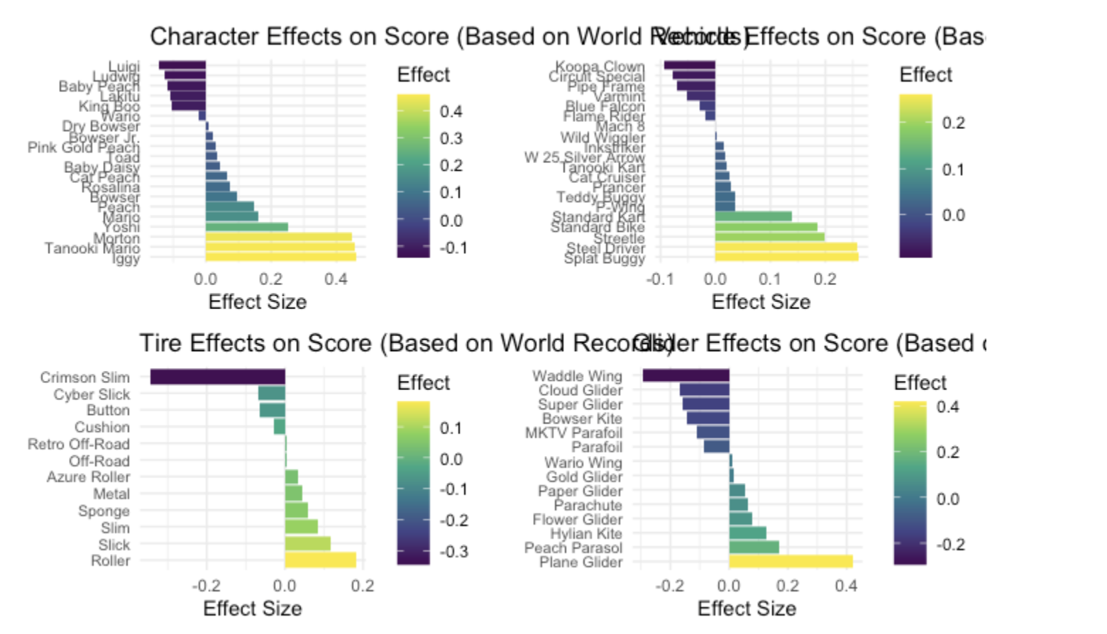
Figure 5: Component Effects on Score

Table 1 shows the top 10 recommended combinations based on the component contribution model. Interestingly, while Morton and Tanooki Mario are represented within these top configurations, there is diversity within the optimal setups. This suggests that there can be multiple pathways to achieve high performance, which gives players flexibility in component selection.
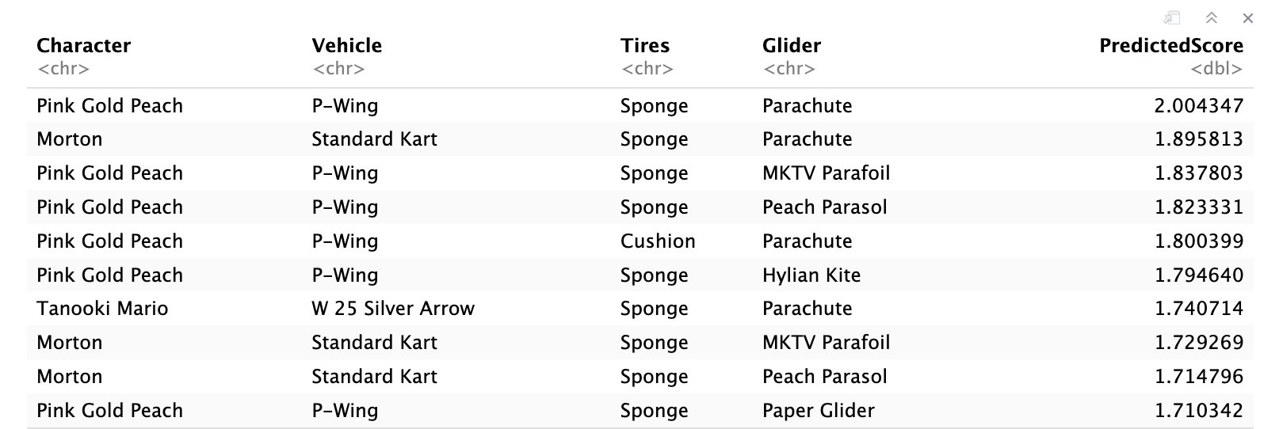
Table 1: Top 10 Combinations using Bayesian

The performance trade off model highlights the relative importance of different attributes to overall performance score. The performance trade off model confirms the negative correlation between certain attributes, such as speed and acceleration. As seen in Figure 6, acceleration showed a positive weight of approximately 0.3, while groundspeed demonstrated a negative weight of -0.6. This demonstrates that optimizing for speed can result in a reduction in acceleration. Furthermore, this explains why configurations focused on either acceleration or top speed, tend to perform better than trying to maximize all attributes.
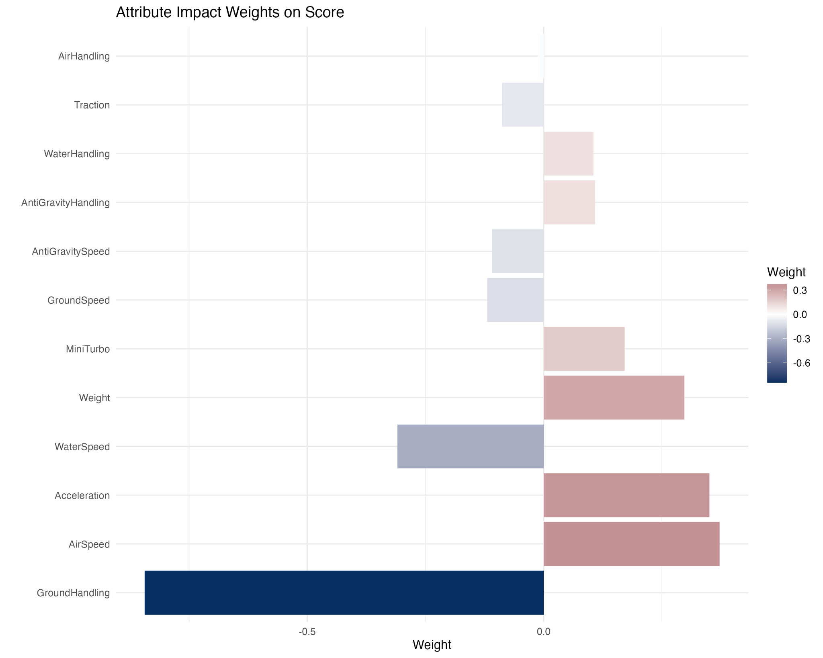
Figure 6: Attribute Impact Weights on Score
Figure 7 shows the character vehicle interactions, through a heatmap.Analysis of character vehicle interactions revealed that certain combinations have better performance benefits beyond their individual contributions. The strongest positive interaction was highlighted between Tanooki Mario and the Streetle vehicle, suggesting that this combination works well. In contrast, Tanooki Mario showed a weak interaction with the Splat Buggy, indicating that these components don’t work well together, despite individual strengths.

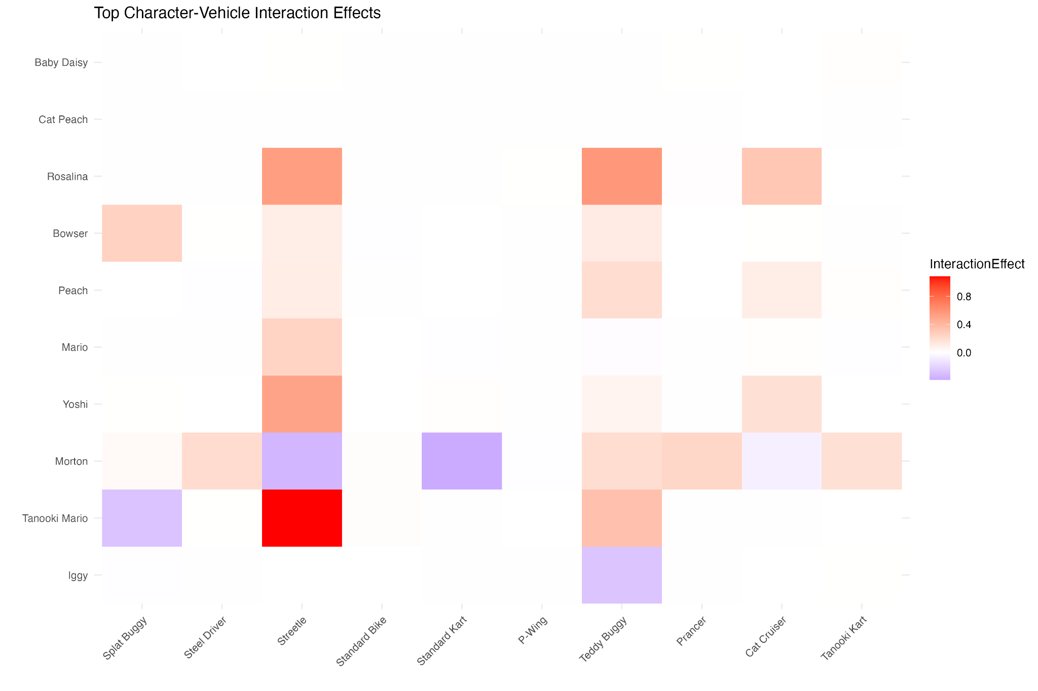
Figure 7: Character Vehicle Interactions

Figure 8 explores the best combination based on attributes. When analyzing the best configurations based on attribution optimization, the three most important attributes for top performance were AirSpeed, Weight, and GroundSpeed. This aligns with the popularity of heavier characters found in the exploratory data analysis, such as Wario and Waluigi. These characters typically perform better with weight and speed attributes.

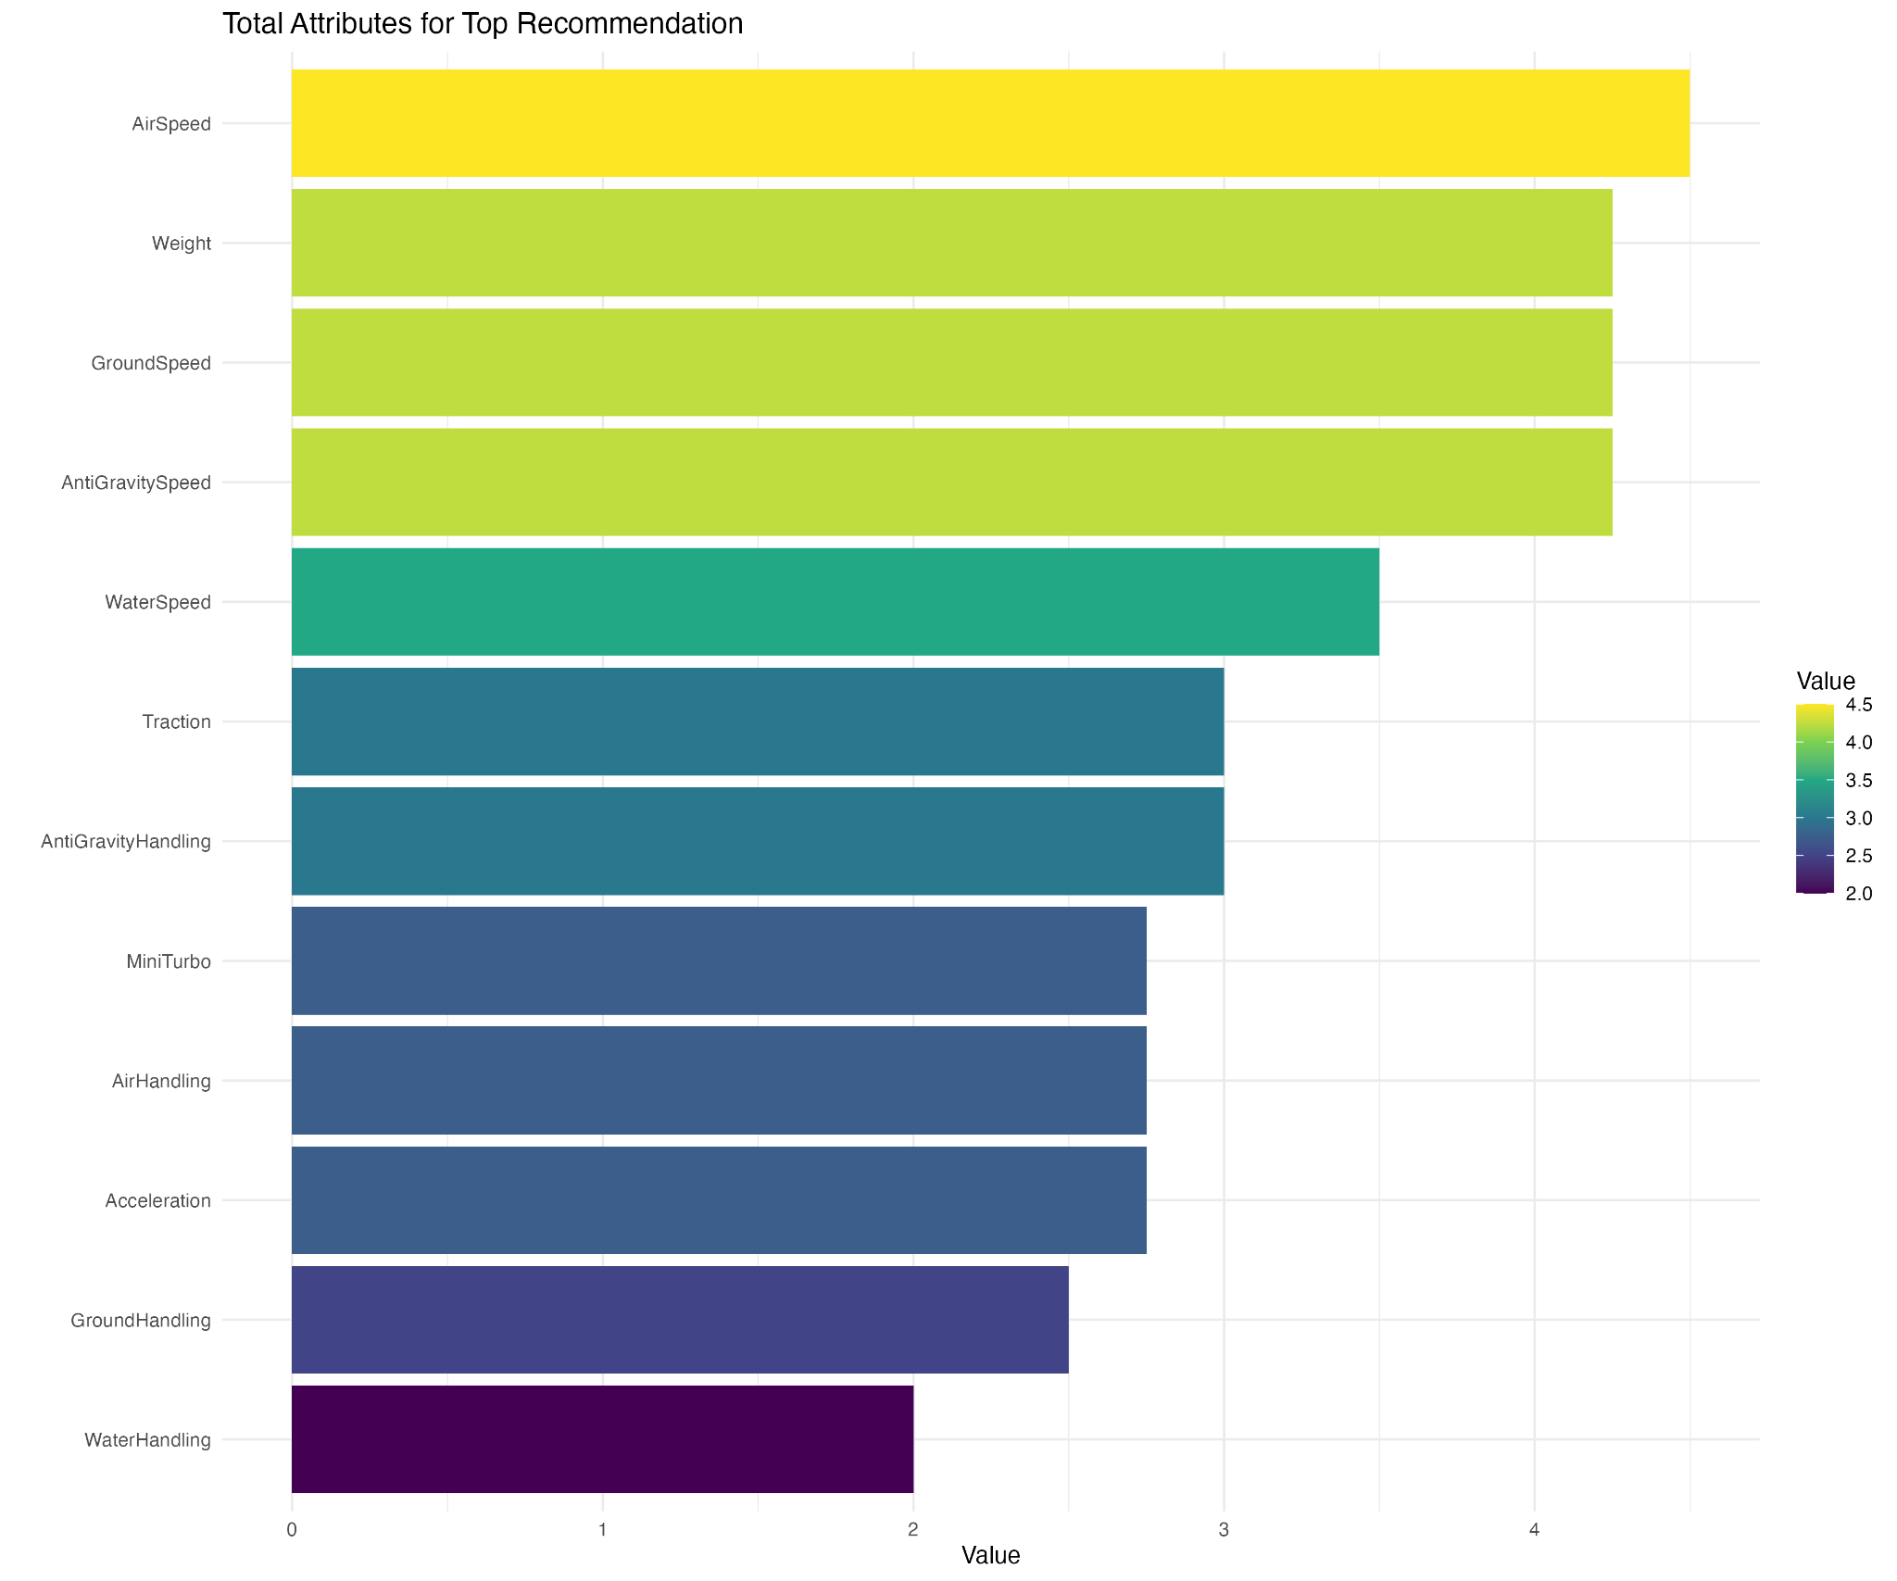
Figure 8: Total Attributes Values
Conclusion

To conclude, this Bayesian analysis of Mario Kart 8 components offers insight into the complex relationship between different components and their combined effect on performance. The results convey that while there are statistically significant configurations, the best setup may depend on player preference, course characteristics, and racing strategy. The frequency of certain components from the world record data, such as the Biddybuggy vehicle and Azure roll tires, is supported by the component contribution model. This identified these items as providing significant performance advantages. The character-vehicle interaction analysis explains why specific combinations appear more frequently. Moreover, the performance trade-off model confirms the game’s speed-acceleration balance, which provides players with more information about the choices to make. Finally, the attribute optimization results emphasize which performance metrics to use when selecting components. Future research could expand this analysis by incorporating course-specific data to identify optimal configurations for different racing environments and by examining the temporal dynamics of component selection as players discover new strategies and techniques.

Future Directions
One future implementation would be to include track characteristics for more specific recommendations. Different tracks in Mario Kart 8 have different levels of curves, surfaces, terrain types(anti-gravity, off-road,etc.) and environmental features, which can impact attributes' level of effectiveness or combination effectiveness. For example, straight speed heavy turns may benefit from high speed setups, while tracks with more sharp turns may benefit from higher handling and mini-turbo. Including track metadata would allow the models to recommend optimal configurations for specific track conditions, which can enhance the precision of the predictions.

Moreover, taking into account “cc” levels can be another beneficial implementation. In Mario Kart 8, “cc” refers to the different speed and difficulty settings for races. The game offers 50cc, 100cc, 150cc, Mirror, and 200cc. Higher cc numbers indicate faster speeds and increased AI opponent difficulty. Mirror mode is 150 reversed. For example, higher “cc” levels may require better traction and handling due to sharper turns and instability.

